StoLaM+
Control validation results

Dr. Tido Strauss
Jana Gerhard
Natalie Dallmann

gaiac - Research Institute for Ecosystem Analysis and Assessment
Kackertstr. 10
52072 Aachen
Germany

July 17, 2024

1 Introduction 3
2 Adaption of control parameters for validation 3
3 Comments on unmet validity criteria 4
4 Results StoLaM 6
4.1 Zooplankton 6
4.1.1 Daphnids 6
4.1.2 Copepod naupli 7
4.1.3 Predatory (cyclopoid) copepods 7
4.1.4 Rotifera 8
4.2 Phytoplankton 9
4.2.1 Total Chlorophyll-a 9
4.2.2 Green algae 9
4.2.3 Diatoms 10
4.2.4 Cryptophytes 10
5 Results IBM Chaoborus 11
5.1.1 Chaoborus crystallinus 11
6 Results StreamCom 11
6.1 Macroinvertebrates 11
6.1.1 Asellus aquaticus 11
6.1.2 Gammarus 12
6.1.3 Gastropoda 12
6.1.4 Cloeon dipterum 13
6.1.5 Chironomus riparius 14
6.2 Total periphyton (chlorophyll-a) 15

Introduction

In this report, based on the previously calibrated StoLaM+ model frameworks, the control model validation is shown and briefly discussed in comparison with the experimental control data for the year 2021 (six control pond replicas).

The simulations always started on 01 January 2021.
The simulations of the pelagic planktonic system were calculated with StoLaM with 50 Monte Carlo simulations each. Chaoborus was simulated with the IBM Chaoborus model with 200 Monte Carlo simulations, the number of Monte Carlo simulations for the benthic invertebrates with the StreamCOM model was set to 100.

The result sections present the simulation results of the modeled taxa for the mesocosm study 2021. The figures integrate the control mean values of the Monte Carlo simulations, the maximum and minimum thresholds of the validation criteria, as well as experimental control mesocosm data (upper graph).

Please note that the evaluation criteria (minimum and maximum abundances) are taken from the controls of previous mesocosm studies, not from the 2021 study presented here.

Adaption of control parameters for validation

The adjustment to the new control data set of the mesocosm study in 2021 was limited to a few parameters of the newly developed submodel for copepods. As the focus was on validating the existing model including its parameters, no further parameters were adjusted and violations of the validity criteria were accepted.

The following few parameters, concerning copepods only, were changed when the model was fitted to the control density data on day 158 (07/06/2021) of the study in 2021:

Selectivity coefficients (pelagic food web)
Nauplii | Cyclotella sp. | 0.2
Nauplii | Chlorococcales | 0.1
Cyclopoid copepodits | Cyclotella sp. | 0.8
Cyclopoid copepodits | Chlorococcales | 0.5
Adult copepods | Cyclotella sp. | 1.0
Adult copepods | Chlorococcales | 0.5

The starting densities of adult copepods on 01.01.2021(day 1) was set on 50 Ind / L.

The weather data were taken from the weather station of RWTH Aachen University with an overall increase of wind speed of 30%, and a decrease of global radiation of 20 %.

Comments on unmet validity criteria

Zooplankton:
The simulation results for the daphnids (IDamP module) are within the minimum and maximum validity limits. The simulated population peak for 2021 is earlier than required by the criteria. However, the field data do not show a clear population dynamic pattern and are overall slightly below the simulated values in 2021.

The DEB-based IBM model for cyclopoid copepods describes the dynamics essentially in the correct order of magnitude, both for the naupliar larvae and for the older stages (copepodites and adults). The overall pattern for the nauplii stages fits well with the measured abundances, whereas the cyclopid copepods show an overestimation of the summer peak with a slight excess of the maximum limit value. Possibly the DEB-IBM model-internal distinction between nauplius stages and young copepodid stages and the associated allocation of individuals to size stages should be re-examined.
Both developmental stages of the copepods show an excessive decline in late summer and fall. This is due to the as yet unbalanced processes of food intake and assimilation. In particular, the mortality module in this IBM for copepods still needs to be improved with regard to DEB parameterization.

The simulated dynamics of small but at times very abundant rotifers (Rotifera_herbivorous2) covers the data range of the experiments. However, the patterns deviate from the experimental data over time. In addition, the model slightly exceeds the maximum limits of the validity criteria in the short term. This summer peak could be avoided by further calibration and is also subject to uncertainty due to the chosen conversion factor between the simulated rotifer biomass and the measured number of individuals. Nevertheless, the timing of the simulated rotifer peak meets the validity criteria, even if the 2021 study does not show this.

Phytoplankton:
Comment: Overall, the measurement of phytoplankton is subject to significant uncertainties for methodological reasons. This is true for the quantification as well as especially for the differentiation of algal groups in phytoplankton via fluorescence measurements.
The green algae meet the validation criteria well. Possibly, in the later course of the mesocosm studies, the algal count is artificially increased by interspersing epiphytic algae from the macrophytes into the phytoplankton samples.
In the StoLaM simulations, the diatoms regularly have a clear peak in spring. Without having any information on possible peaks before the experimental period of the mesocosm study, the chlorophyll-a content of the diatoms is well met during the experimental phase, even if the diatoms in the study were estimated to be slightly lower than in the simulation.
In contrast, the cryptophytes show higher chlorophyll-a contents in the study than were simulated. Nevertheless, the simulations were still within the range of the validity criteria except for a few days with a minimal excess of the validity threshold.
The total phytoplankton meets also the validation criteria.

Simulations with the IBM Chaoborus module:
The larval density of Chaoborus is within the range of the measured data, which show high variability without clear population dynamic patterns in the Mesocosmos study.
Although the simulated abundance in 2021 exceeds the upper limit of the validity criteria, many measured values in the 2021 study are also well above the maximum value extracted from the older control studies.

Benthic macroinvertebrates:

Asellus meets the requirements of the validation criteria and is in line with the overall pattern of the experiment.
The simulated dynamics for Gammarus exceed the upper validity criteria by a few animals per m², during the course of the study. However, no data on Gammarus are available in the 2021 study.
For the gastropods, represented by Lymnea stagnalis, the requirements of the validation criteria were met. The simulation slightly overestimates the abundance in 2021 and reproduces the field data satisfactorily in its dynamics.

For the mayfly species Cloeon dipterum, the dynamics of cumulative emergence is in the range of the previous control data sets, and reached similar cumulative numbers per m² as in the study 2021. The dynamics of the larvae also give a consistent picture, as long as a conversion factor of 10 is assumed, which was derived from the control calibrations. If this conversion factor for larval abundance in the mesocosms derived from the emergence data and modeled life cycles is accepted, the simulated larval densities and cumulative emergence for 2021 are still within the vailidity criteria.

For the chironomids a similar picture as for Cloeon was obtained. Here, we used again the former calibrated conversion factor for the larval abundance per m² of 880.
However, in the 2021 mesocosm study, the sampled number of chironomid larvae were much higher than in the previous studies used for model calibration and extraction of the validity criteria. This possibly indicates a slightly higher larval catchability in the 2021 mesocosm study, whereas the quantification of larval abundance remains a major uncertainty for Chironomus.
As in the calibration studies, the simulated larval densities in 2021 using the adjusted conversion factor remain within the range of the validity criteria. The simulated cumulative emergence is again within the range of the calibration data sets, although the sum of the chironomids is lower.

The requirements of the validation criteria for total periphyton were met also for the year 2021. However, there is a large uncertainty in the quantification of periphyton, as exemplary measurements on the mesocosm wall indicate a significantly increased periphyton biomass over the year compared to the used measurements on glass slides. Additionally, algal availability to benthic grazers on sediment and macrophytes has not been quantified. Therefore, there is a large source of uncertainty given for the benthic food web modelling.

Results StoLaM

Zooplankton

Daphnids

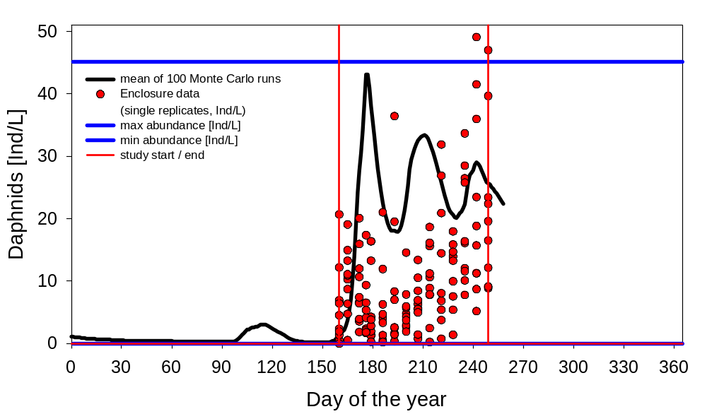
Figure 4.1 Daphnia magna 2021

Copepod naupli

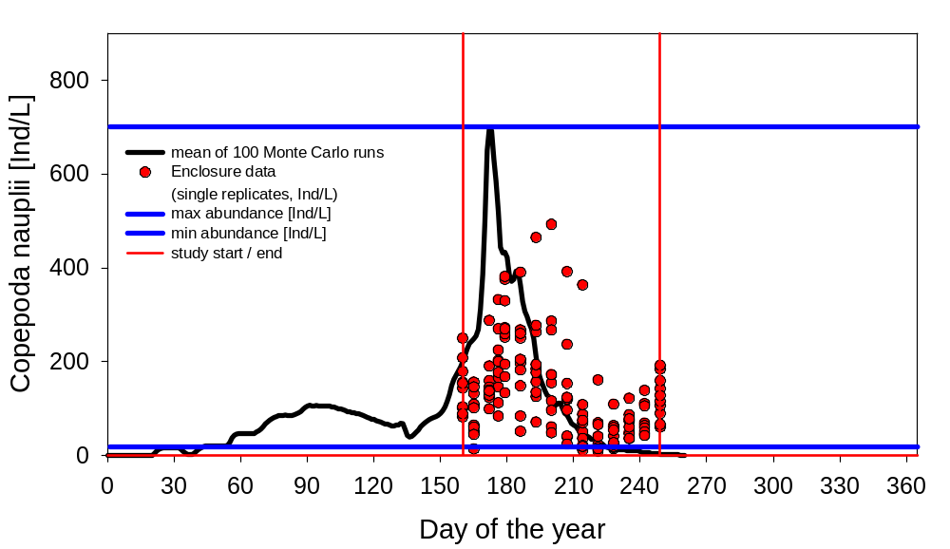
Figure 4.2 Copepod nauplii 2021

Predatory (cyclopoid) copepods
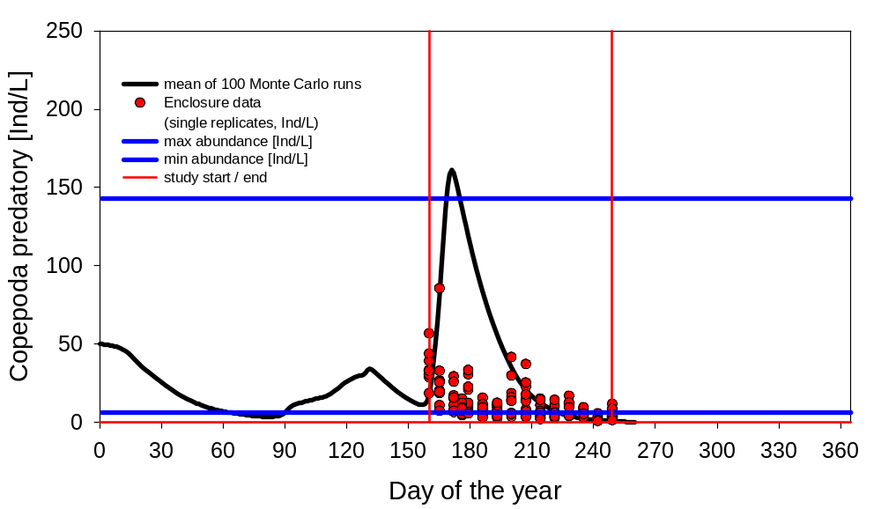
Figure 4.3 Mesocyclops leuckarti 2021

Rotifera

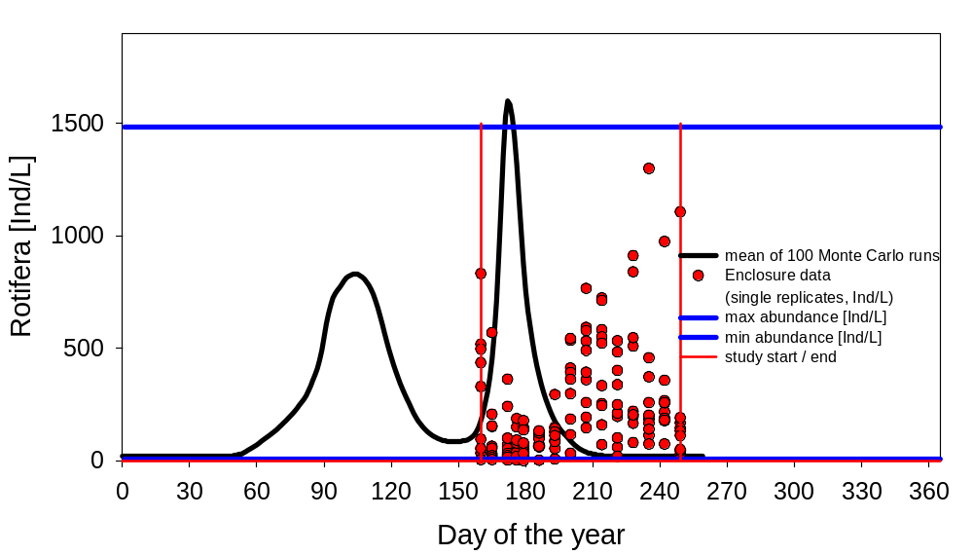

Figure 4.4 Rotifera (Keratella cochlearis) 2021

Phytoplankton

Total Chlorophyll-a

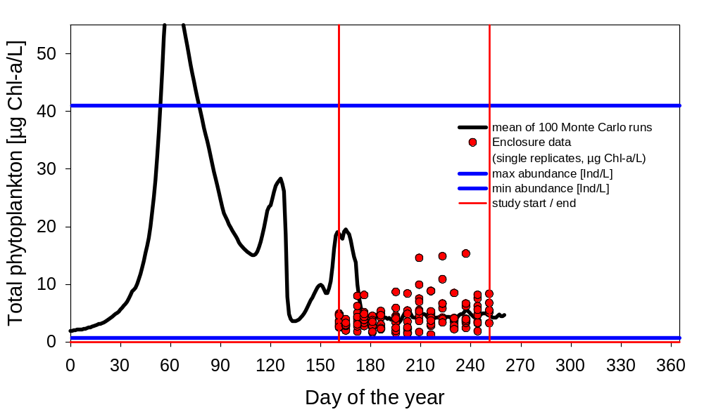

Figure 4.5 Total chlorophyll-a 2021

Green algae

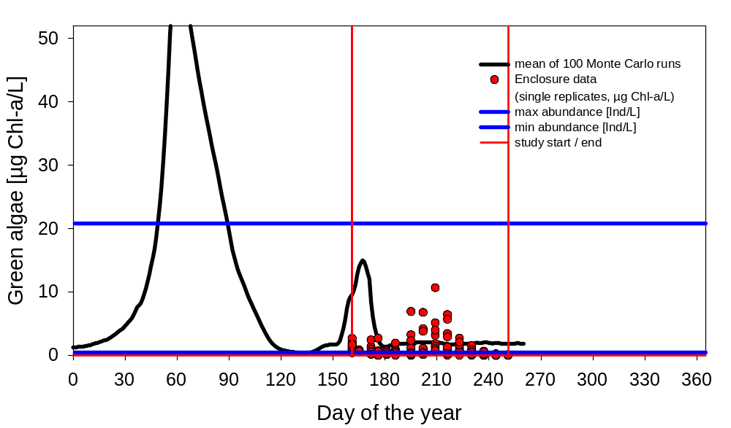
Figure 4.6 Green algae 2021

Diatoms

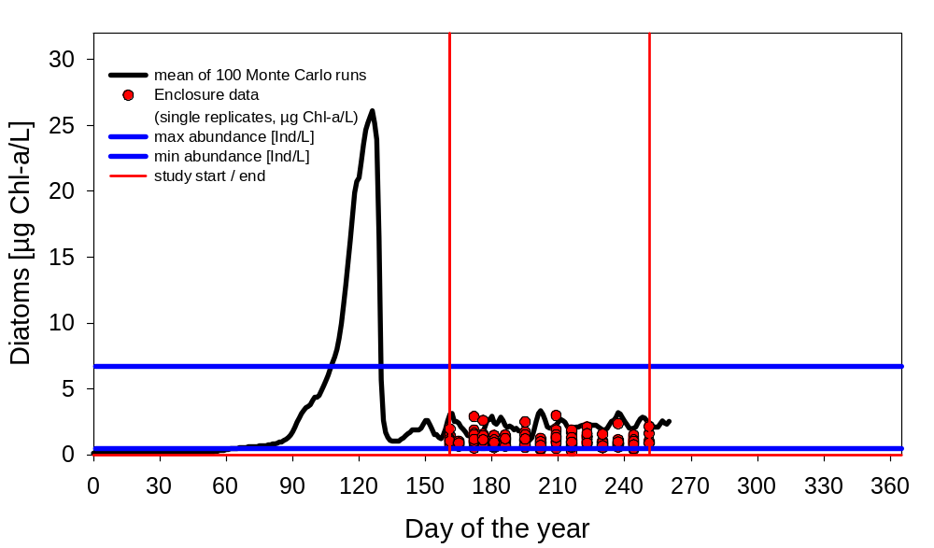
Figure 4.7: Diatoms (Cyclotella) 2021

Cryptophytes

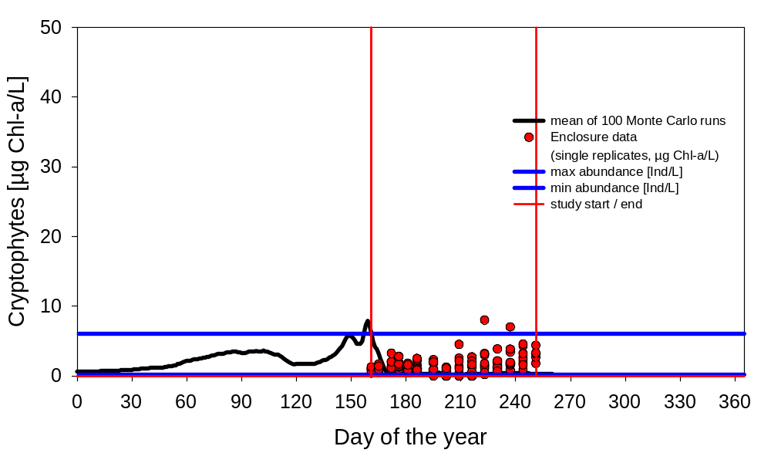
Figure 4.8: Cryptomonas 2021

Results IBM Chaoborus

Chaoborus crystallinus

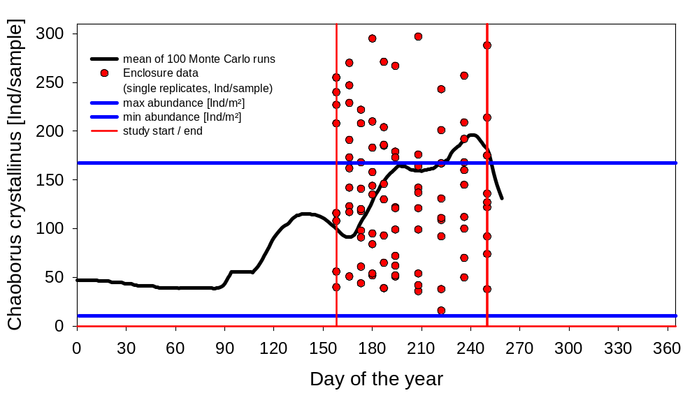
Figure 5.1: Chaoborus larvae 2021

Results StreamCom

Macroinvertebrates

Asellus aquaticus
For Asellus, a conversion factor of 0.5 was used for the measurements and simulations in the figures.

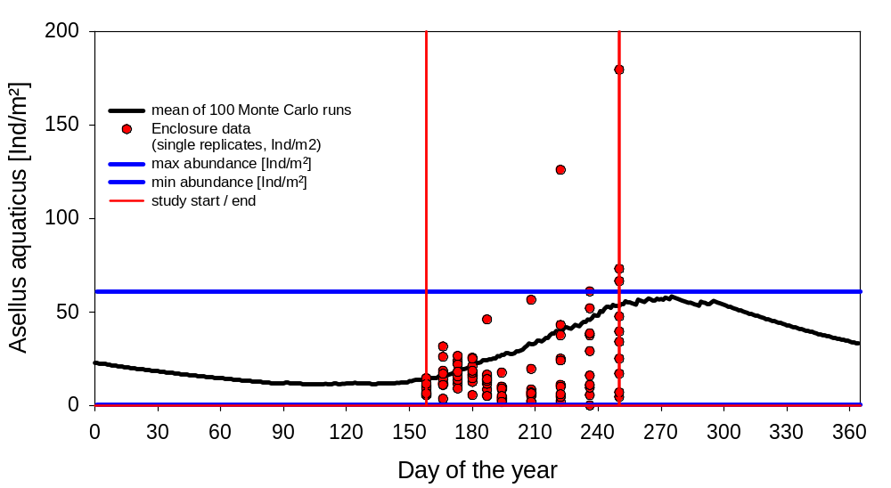
Figure 6.1 Asellus aquaticus 2021

Gammarus

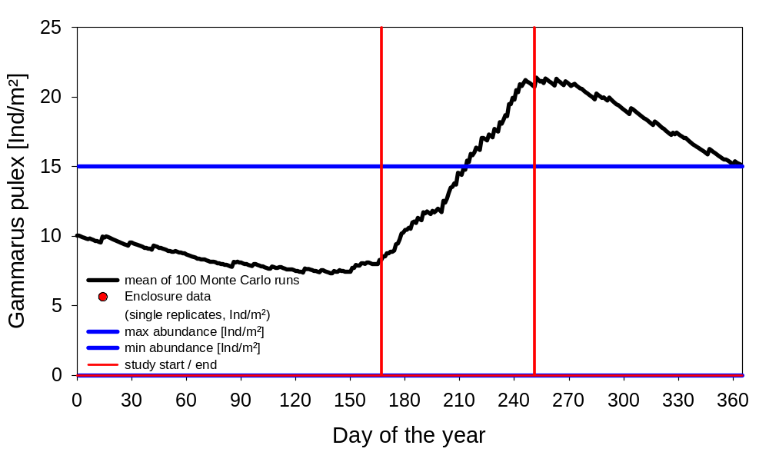
Figure 6.2: Gammarus pulex 2021

Gastropoda

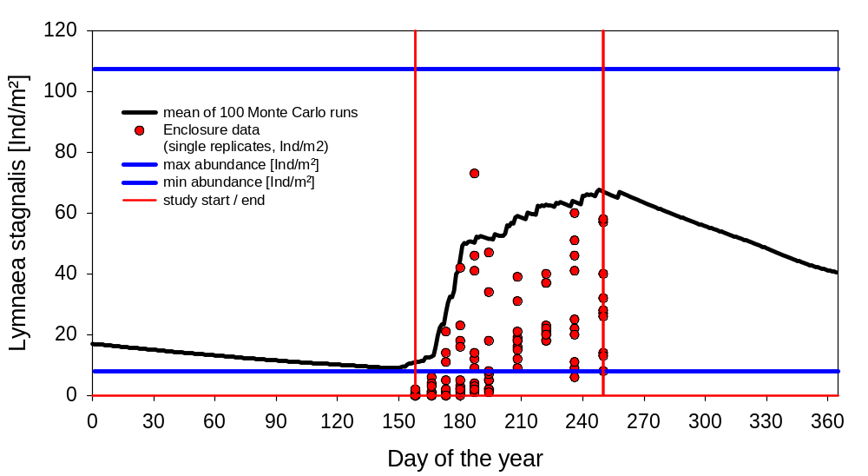
Figure 6.3: Lymnaea stagnalis 2021

Cloeon dipterum
For Cloeon larvae, a conversion factor of 10 was used to display the measurements and simulations in the figures.

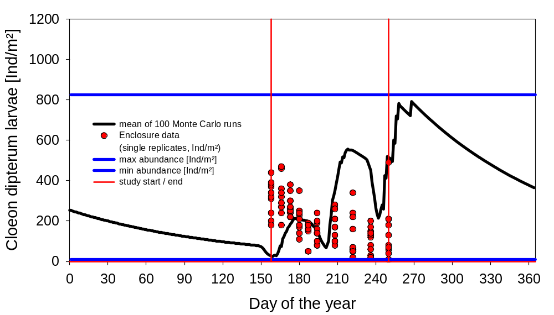
Figure 6.4: Cloeon dipterum larvae 2021

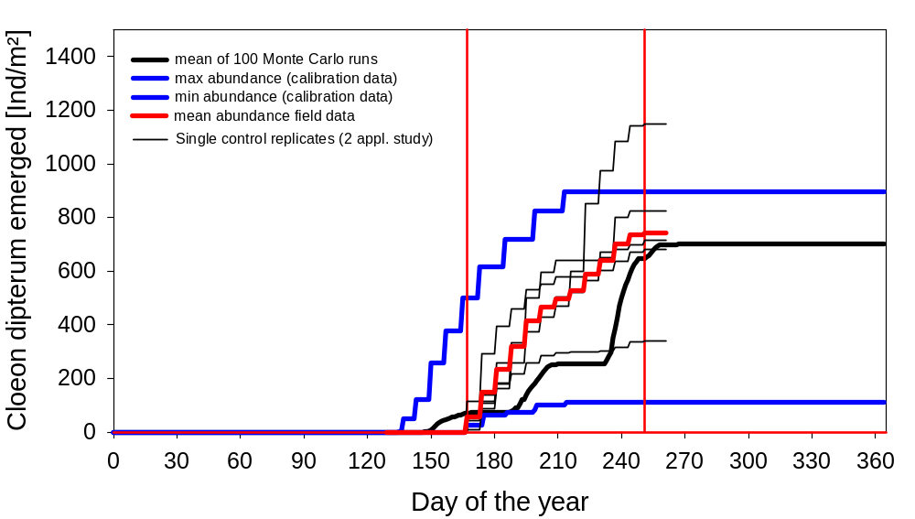
Figure 6.5: Cloeon dipterum – cumulative emerged adults 2021 (experimental data only from 5 controls of the 2 applications-study)

Chironomus riparius
For Chironomus larvae, a conversion factor of 880 was used to display the measurements and simulations in the figures.

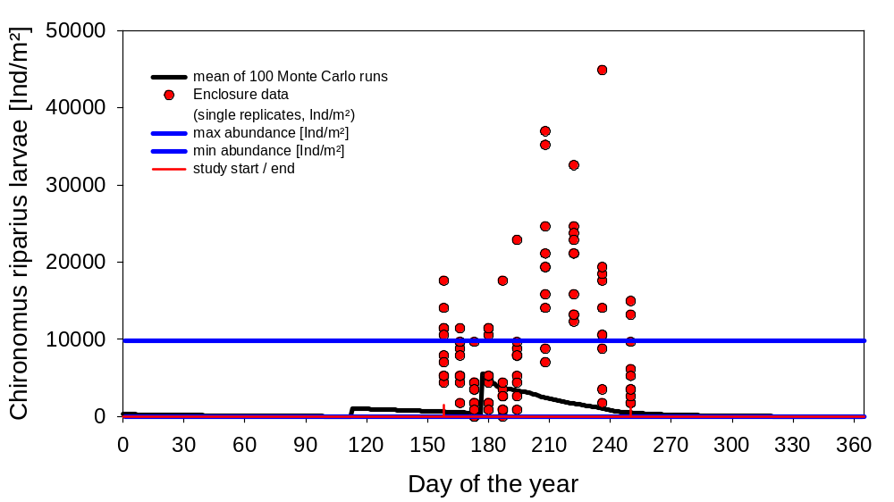
Figure 6.6: Chironomus riparius larvae 2021

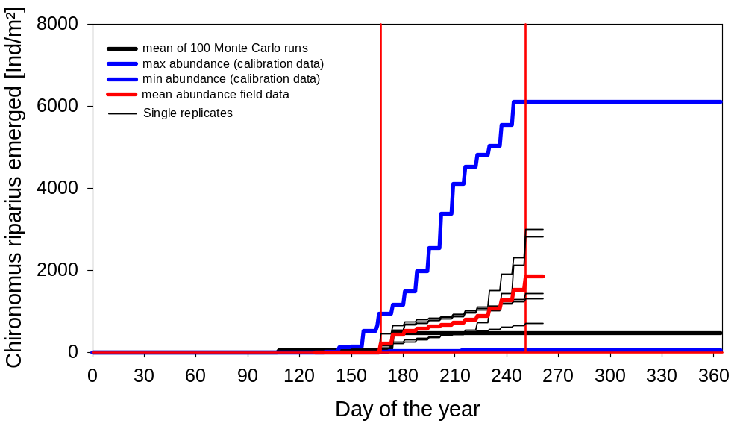
Figure 6.7: Chironomus riparius – cumulative emerged adults 2021 (experimental data only from 5 controls of the 2 applications-study)

Total periphyton (chlorophyll-a)

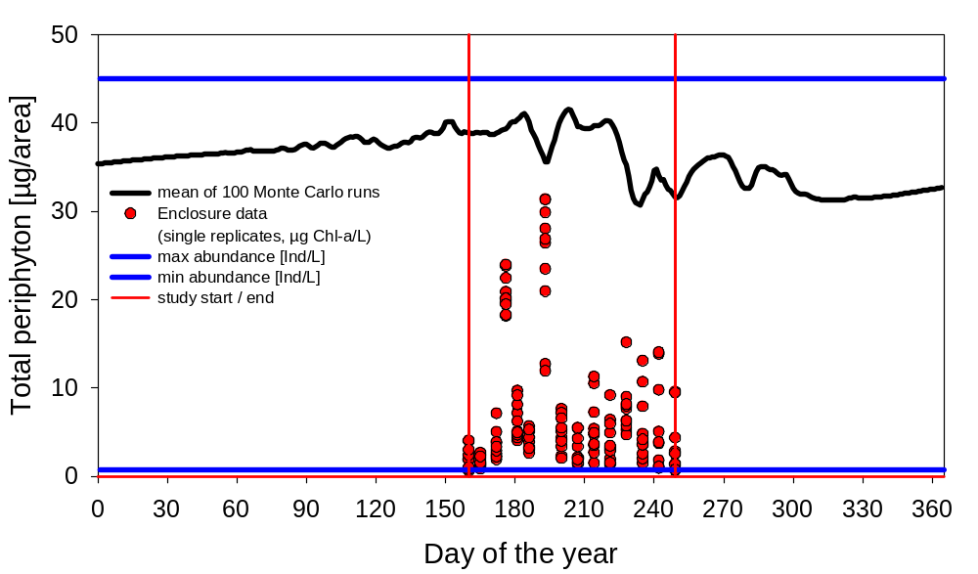
Figure 6.8: Total periphyton (chlorophyll-a) 2021

